_____________________________________________

**Software Design Document**

**for**

**Food Management System**

**Prepared by**

Group7

Arun B chandran-14

Jyothis S -37

Deepak P-76

Asa Shijil-75

**TKM College of Engineering**

**Table of Contents**

**1. Introduction 3** 1.1 Purpose 3 1.2 Scope 3

**2. System Architecture Design 4**

**3. GUI Design (Mockups) 10**

**4. Database Design 12**

**5. System Requirements 14**

**6. Conclusion 14**

**1. Introduction:**

The Food Management System is a web-based application that helps to manage the food in hostels, catering areas, and hotels. The system provides a platform to display extra food available in the hostel or catering area. Delivery persons from social services will deliver the food without any delivery fee. The application is built using Django technology. This system not only benefits the public but also helps orphanages and other organizations get food donations. Social workers can use this platform to take food and distribute it to those in need, making sure no food goes to waste. The system also helps organizations manage their food inventory efficiently and track their food waste, promoting sustainable and responsible food practices.

**1.1 Purpose:**

The purpose of the food management system is to reduce food waste and help orphanages and other organizations get extra available food. Social workers can also use this system to obtain food and distribute it to those in need. The system allows users to view the extra food available in hostels, catering areas, and hotels.

**1.2 Scope:**

The scope of the project includes developing a web application that will allow hostels, catering areas, and hotels to upload their extra available food to the system. Users can view the available food and place an order for delivery. The system will track the location of the delivery boy and the user's location for timely delivery. The system will also have an administration panel that will allow administrators to manage the food listings, users, and delivery boys. The system will be accessible to users from anywhere and will be available 24/7.

**2. System Architecture Design:**

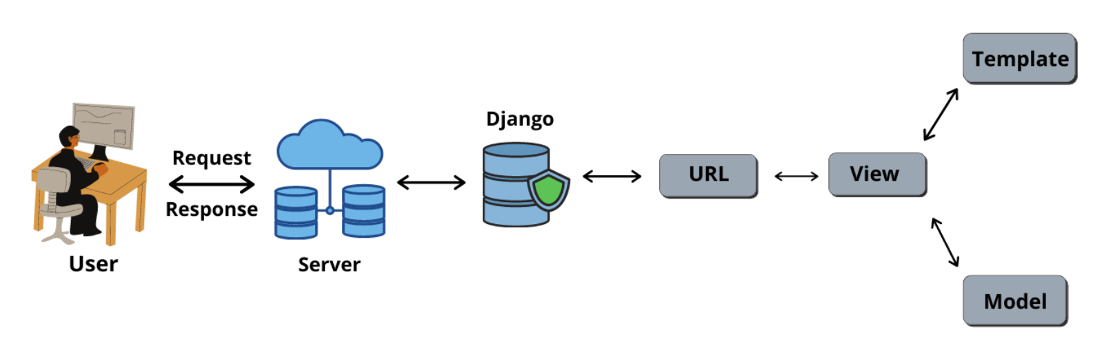

The system architecture design for the food management system includes the following components:

1. Food donors (hotels, hostels, catering):

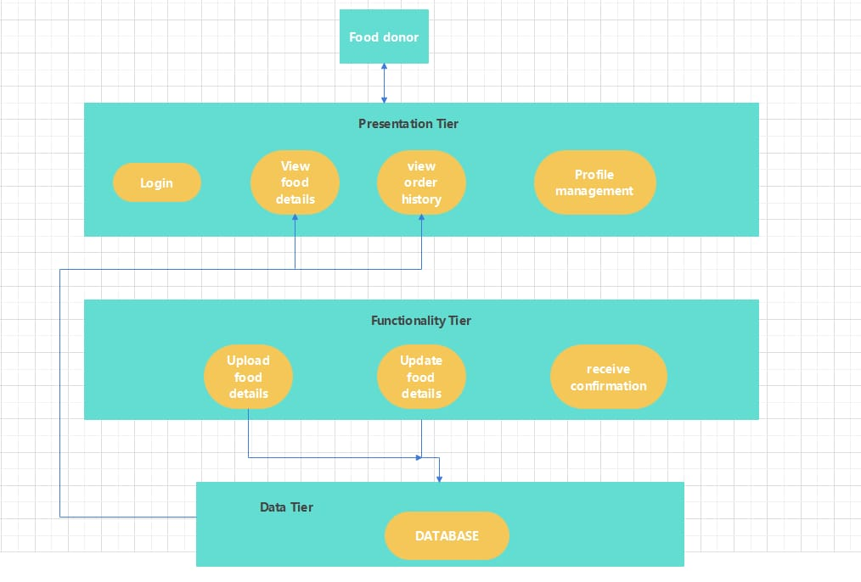

a. View Food Details: Food donors can view the food details they have

uploaded, which includes the food count, menu, and quantity.

b. View order history: Food donors can view their order history and keep

track of the food they have donated.

c. Profile management:

1.View profile: Allow the food donor to view their profile information,

including name, email address, contact number, and address.

2.Edit profile: Allow the food donor to edit their profile information

and update it.

3.Change password: Allow the food donor to change their password

for their account.

4.Delete account: Allow the food donor to delete their account from

the Website

d. Upload Food Details: Food donors can upload details about the extra

food they have available, such as food count, food menu, and quantity.

e. Update Food Details: Food donors can update the food details whenever

there is a change in the food count, menu, or quantity.

f. Receive Confirmation: Once a social service accepts the food distribution

request, food donors will receive confirmation of the acceptance.

1. Food Distributors (social workers, other social service volunteers ):

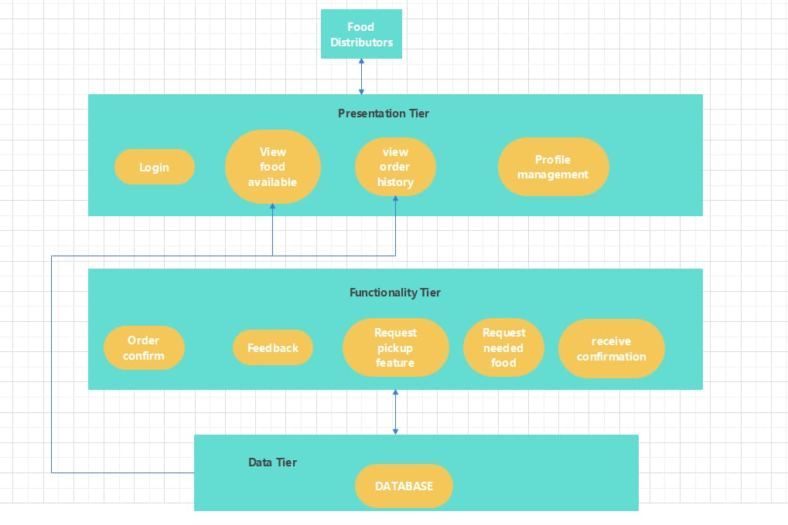

a. View Food Available: Food distributors can view the details of food

uploaded by food donors, which includes the food count, menu, and

quantity.

b. View Order History: Food distributors can view their order history and

keep track of the food they have distributed.

c. Profile management:

1.View profile: Allow the food distributors to view their profile

information, including name, email address, contact number, and

address.

2.Edit profile: Allow the food donor to edit their profile information

and update it.

3.Change password: Allow the food donor to change their password

for their account.

4.Delete account: Allow the food donor to delete their account from

the Website

d. Request pickup of food: Food Distributors can request for the pickup of

the food from the food donor’s location.

e. Order confirmation: After the food donor has accepted the food pickup

request, the food distributors will get the confirmation request.

f. Feedback: Food distributors can give feedback about the food donors.

g. Request needed food: Food Distributors can request food, and others

users can donate food.

h. Receive confirmation of requested food: Food Distributors will get

confirmation when other users confirm a donation.

1. Normal Users:

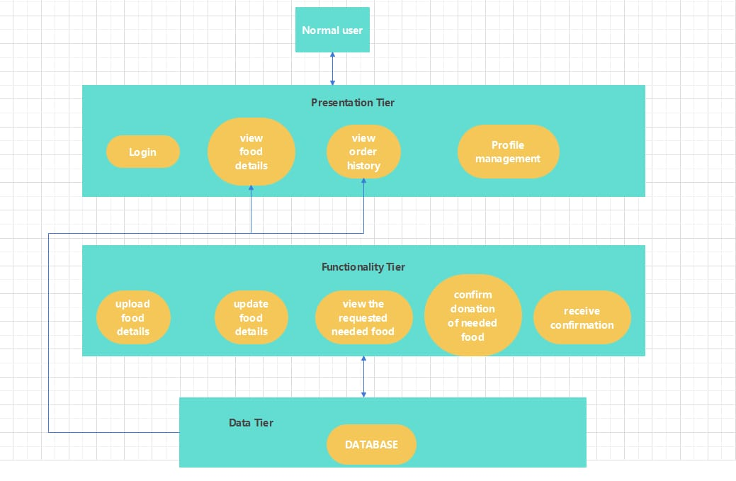

a. View food details: Normal Users can view the food details they have

uploaded, which includes the food count, menu, and quantity.

b. View Order History: Normal Users can view their order history and keep

track of the food they have donated.

c. Profile management:

1.View profile: Allow the Normal Users to view their profile

information, including name, email address, contact number, and

address.

2.Edit profile: Allow the Normal Users to edit their profile information

and update it.

3.Change password: Allow the Normal Users to change the

password for their account.

4. Delete account: Allow the Normal Users to delete their account

from the Website

d. Upload Food Details: Normal Users can upload details about the extra

food they have available, such as food count, food menu, and quantity.

e. Update Food Details: Normal Users can update the food details

whenever there is a change in the food count, menu, or quantity.

g. View the request for needed food: Normal Users can view the request

for needed food

h. Confirm donation for needed food: Normal Users can confirm the

requests.

3 User types with their functions:

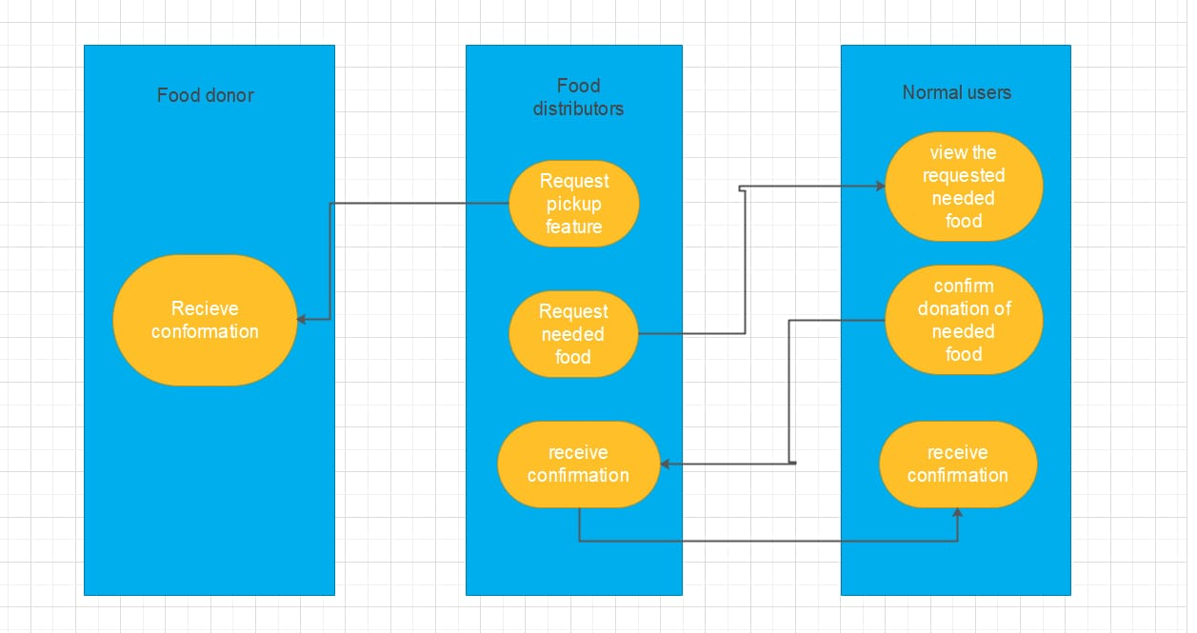

**3. GUI Design (Mockups):**

The GUI design of the Food Management System includes the following pages:

1.Home Page: The home page displays the available food in the hostel or catering area. It also provides an option to request food.

2.Request Page: The request page allows the user to select the food they want to request and provide their details.

3.Delivery Page: The delivery page displays the delivery person's location and provides an option to track the delivery.

4.Signup Page: The signup page allows users to create an account.

5.Login Page: The login page allows users to login to existing account.

6.Profile Page: The profile page displays all the user details.

7.Settings Page: Settings page allows to update or change the user details.

Signup Page:

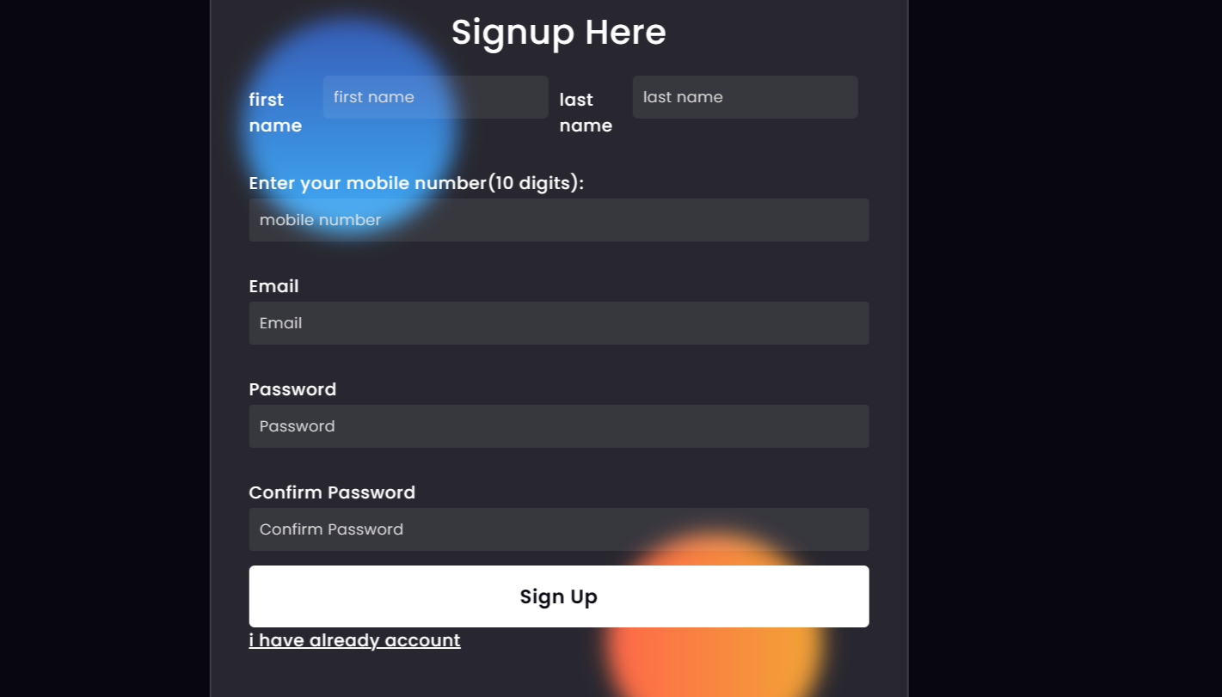

Login page:

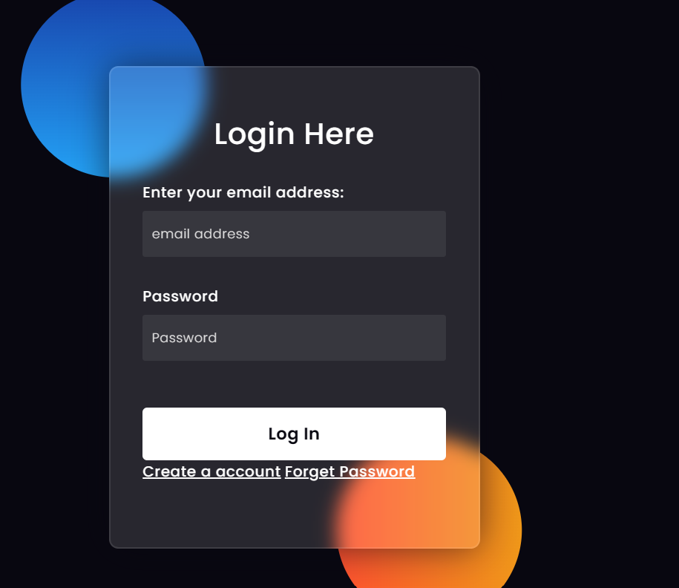

**4. Database Design:**

The database schema of the Food Management System includes the following tables:

User: Stores the user's details, such as name, email, and phone number.

Menu: Stores the available food details such as food name, food count, and food menu.

Orders: Stores the user's request details, such as food name, quantity, and delivery address.

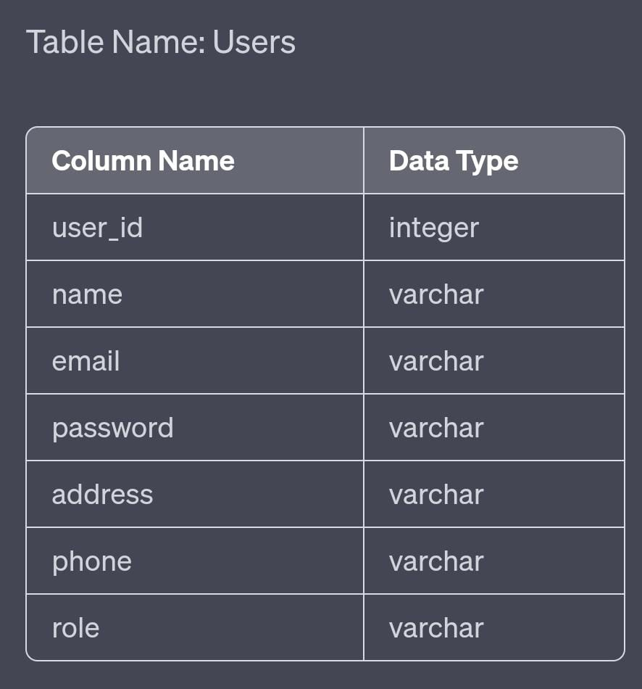

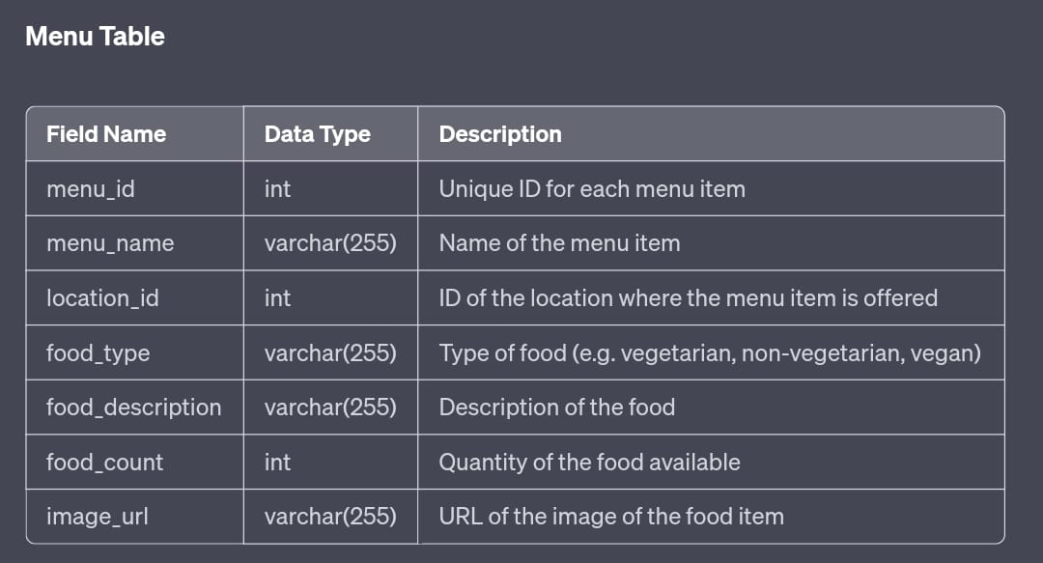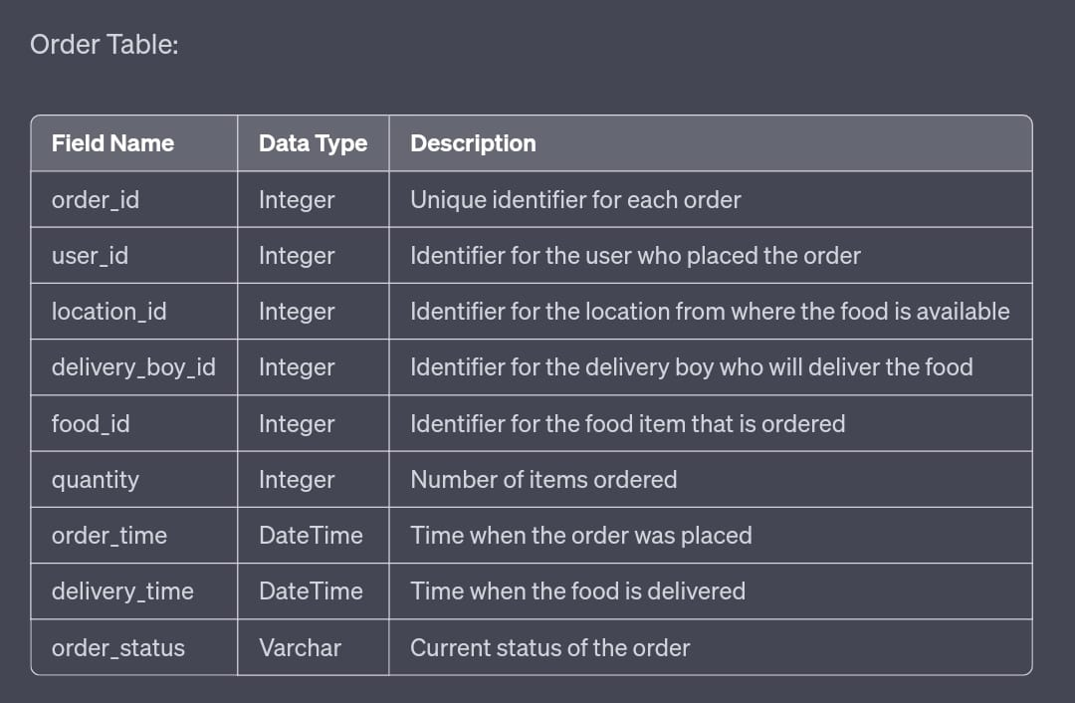

**5. System Requirements:**

The following are the system requirements for the Food Management System:

1. Frontend - HTML, CSS, JavaScript

2. Web Framework - Django

3. Programming Language - Python

4. Database - MySQL.

**6. Conclusion:**

In conclusion, the food management system is a web-based application that efficiently manages excess food in hostels, hotels, and catering areas. This project can be beneficial for orphanages and other organizations that require food donations. Social workers and organizations like the National Service Scheme (NSS) can take advantage of this system to collect and distribute food to people in need. The food management system is an effective solution to the problem of food waste and promotes the concept of sustainability. It ensures that excess food is utilized effectively, preventing it from going to waste. Overall, this project has the potential to make a positive impact on society and the environment, and it can be especially useful for those working to help the less fortunate.